West Pennine Moors Biodiversity Report 2012-13
Continuing the actions started the previous financial year United utilities has invested in the moorland infrastructure in an effort to reduce the potential for uncontrolled moorland fires.
1800m of moorland track has been renewed at Well Lane and Withnell Villa on Withnell Moor and a further 1000m at Slater lane on Anglezarke Moor. This will facilitate easier access for equipment and in conjunction with the annual fire break mowing and the successful grip blocking work undertaken in 2011/12 will improve the fire break measures at key locations.
In partnership with the Lancashire Fire Operations Group UU has updated its’ Fire Plans, and contributed to the cost of “stub” pouches which can be given to smokers at moorland access points at times of high fire risk along with free advice on fire risk.
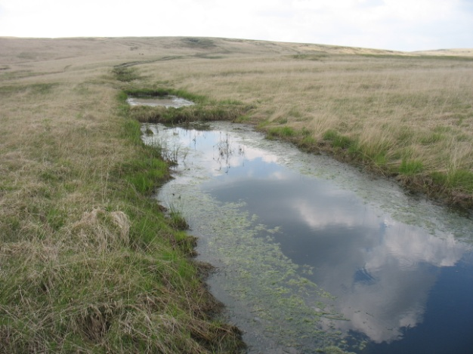
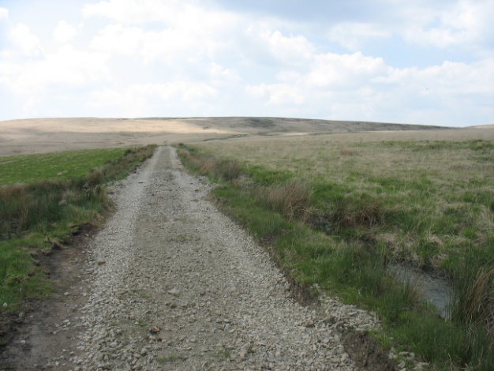

Slater Lane photos Ian Harper
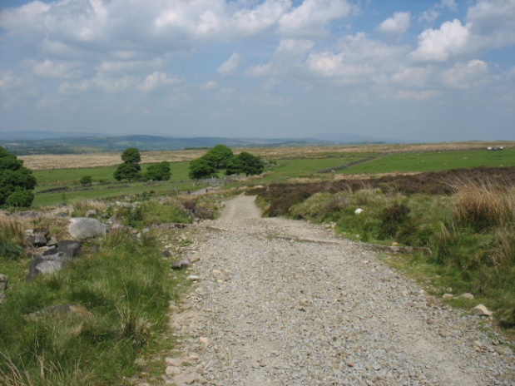
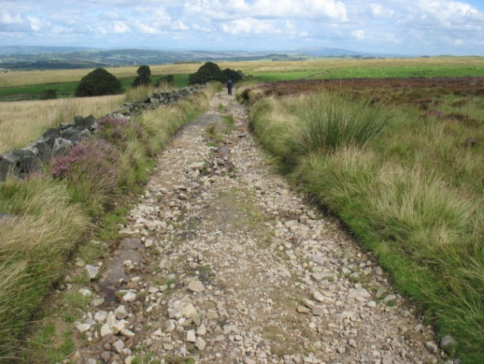

Well Lane before and after renewal photos Ian Harper
On a less positive note the problem of fence cutting has continued to blight measures to control stock trespass. Some fence renewals this year have been cut several times allowing trespass sheep to graze in excluded areas or worse still allowed stock out onto the road. The problem was highlighted by the Company’s tenant Mr. J Drinkall of manor House Farm, Anglezarke who found several sheep caught up in short sections of barbed wire which had been cut out of fences and discarded on the floor. This is an animal welfare issue and a health and safety issue for staff handling the sheep and especially dangerous at shearing time when pieces of wire can be hidden in the fleece. Despite a press release about the issues and regular monitoring of the target sites the problem still persists in the Anglezarke, Rivington and North Turton / Darwen areas.
The black headed gull colony on the island at Belmont Reservoir remained stable with approximately 7000 breeding pairs. Included in the colony were 14 breeding pairs of Mediterranean Gulls and a single pair of Lesser Black backed Gulls. Thanks to those who have assisted with the counts, monitoring and habitat works which make this such a valuable breeding site.
Although the brown hare monitoring 1km squares have not provide much in the way of sightings ad hoc records are demonstrating the value of the Scapm2 works taking place across the catchments especially the woodland planting schemes in the cloughs and valleys which are providing a more diverse habitat.
At Higher Pasture House Farm, Belmont approximately 300m of hedgerow was laid. These hedges were planted about 15 years ago as part of WPM’s / Counmtryside Stewardship Scheme initiative. A further 300m will be laid in a couple of years time. Bolton Conservation Volunteers again had a winter task at Entwistle Reservoir laying and underplanting the hedgerow on the eastern side.
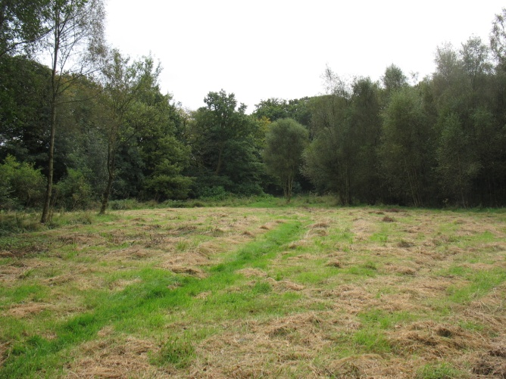
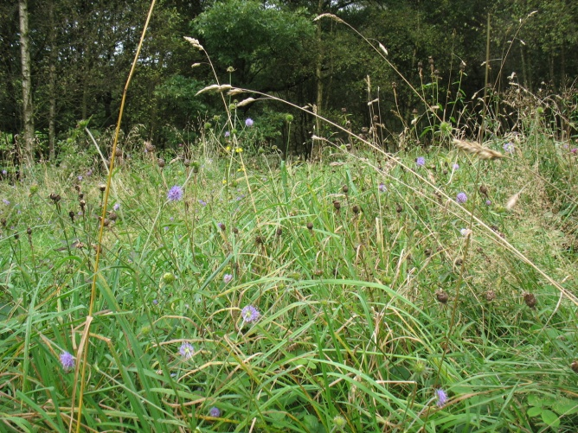
After entering the Tennis Court field at Dean Wood, Rivington into the Forever Meadows project the first hay cut was made in early August. Despite the wet weather conditions a short window was found for a contractor to get onto the field to make the cut. However the weather then turned wetter and the arisings had to be removed by hand. A team of volunteers from Lancashire Wildlife Trust did a good job of clearing the site.

Photos Ian Harper
Roadside dry stone walls suffered quite a considerable amount of damage due to accidents in the snow and ice. Theft of stone still poses a problem across the West Pennine Moors with the A666 being a particular target area. In other areas the Bolton Conservation Volunteers have been repairing some of the internal walls on the field system at Sheephouse Lane, Rivington.
Work to remove non native invasive species has continued. UU assisted the Lancashire Wildlife Trust with the survey of the River Douglas corridor and also The Conservation Volunteers with work on the River Yarrow corridor. Contractors were once again active at Roddlesworth and Charters Moss removing balsam.
Ian Harper Biodiversity Officer June 2013

